|  |  |  |  |  |  |
| --- | --- | --- | --- | --- | --- |
|  |  |  |  |  | logo1.png |

|  |  |  |  |
| --- | --- | --- | --- |
| Course Name | | Graphic Designing with canva | |
| College Name | | Mangayarkarasi College of Arts and Science for Women Paravai, Madurai - 625002 | |
| College Code | | MKU251 | |
| Skill Offering Id | |  | |
| Project Title | | Create A Social Media post | |
| Project Submitted To | | Madurai Kamaraj University ( Naan Mudhalvan Scheme(TNSDC)) | |
| Year | | 2023 | |
| Department | | B.A English Literature | |
| Semester | | 5 | |
| Group Number | | 12 | |
| Total Members of the Group | | 4 | |
| Group Members Details | | | |
| Name of the Member | University Register. No | | Student NM ID |
| B.Vikashini | MKU251C1A17455 | | 5A6A5AA26AD418780104C6E584076923 |
| M.Valarmathi | MKU251C1A17453 | | 5EE599EF702DAC398E6467F2D2CB22D4 |
| M.Vanmathi | MKU251C1A17454 | | 520E991AD167DD087E34359055B70E78 |
| P.Visithra | MKU251C1A17456 | | A3BE6CBC14EBD5F867A4F6065CC06AE1 |
|  |  | |  |
| Under the Guidance | |  | |
| SPOC | | Ms.P.UMADEVI | |

**ANALYSING HOUSING PRICES IN METROPOLITAN AREAS IN INDIA**

1. **Introduction.**
   1. **Overview**

**Each social network offers different options for presenting content. Many social media marketers manage and share social media posts across multiple social platforms. They are using it for personal relationships and entertainment, for work and research, and business communication.**

* 1. **Purpose**

**People are using social media for a variety of purposes. The four main uses of social media form the acronym SLIM: sharing, learning, interacting, and marketing.Social media marketing is the use of social media websites and platforms to promote products and services and connect with audiences.**

1. **Problem Definition and Design Thinking**
   1. Empathy Map

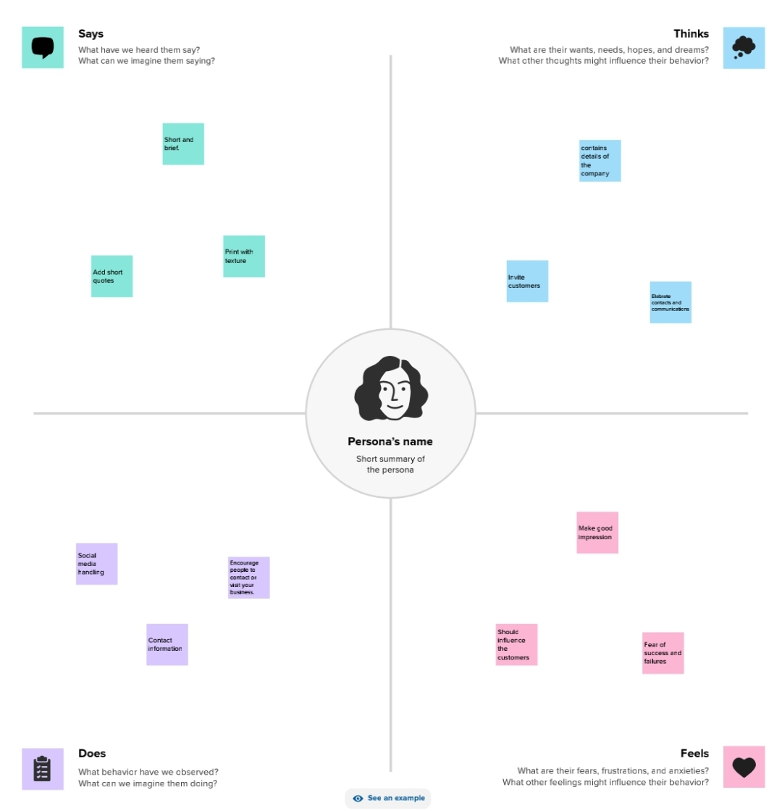

**2.2 Ideation and Brainstroming Map**

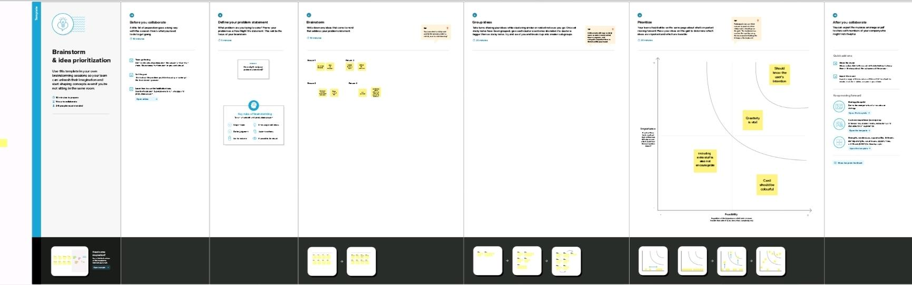

**Mile stone 1 :**

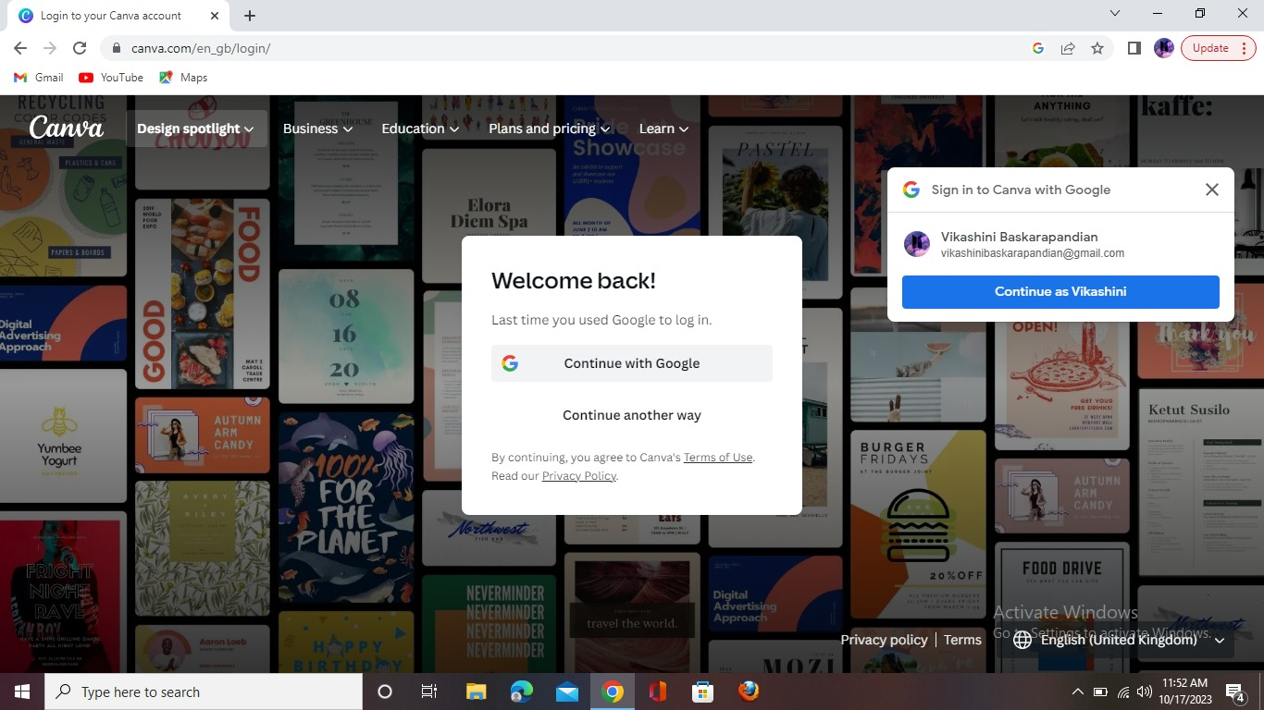

**Mile stone 2:**

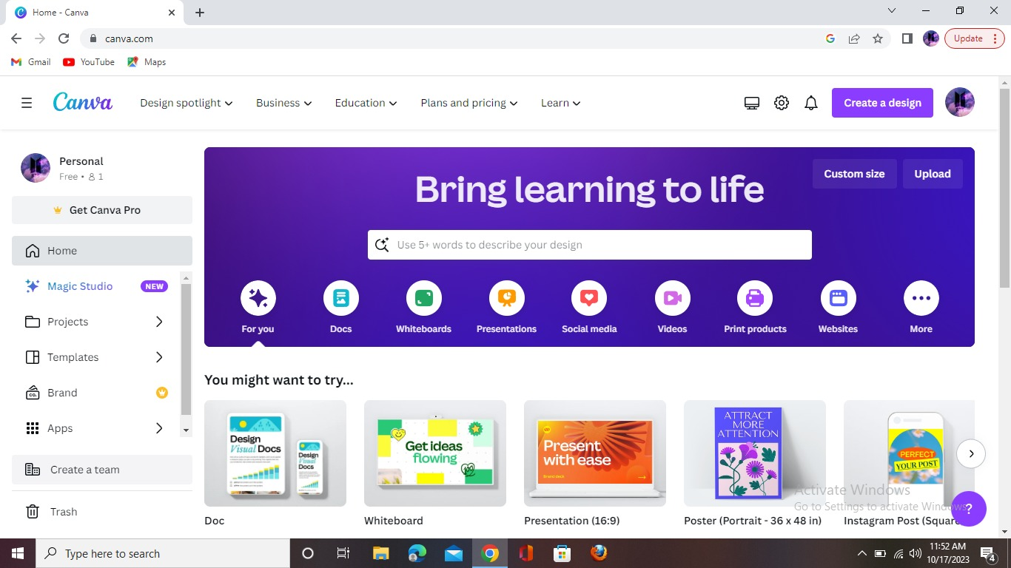

**Mile stone 3:**

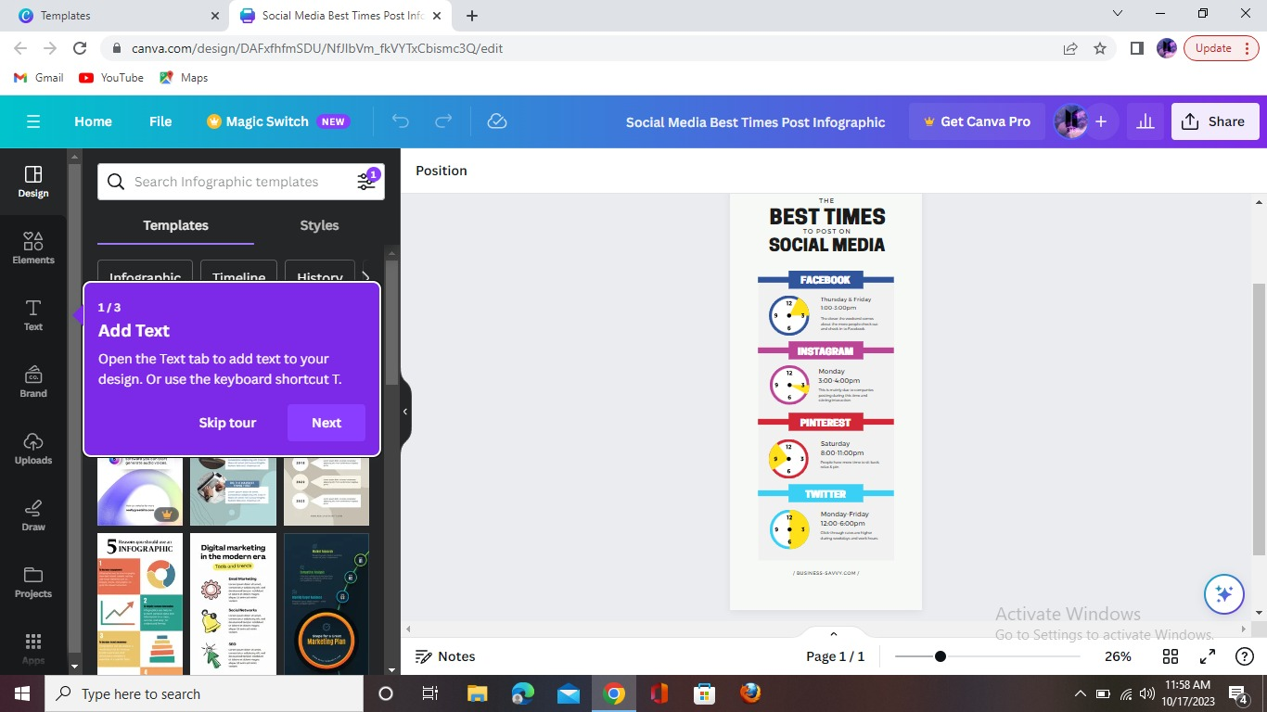

**Mile stone 4 :**

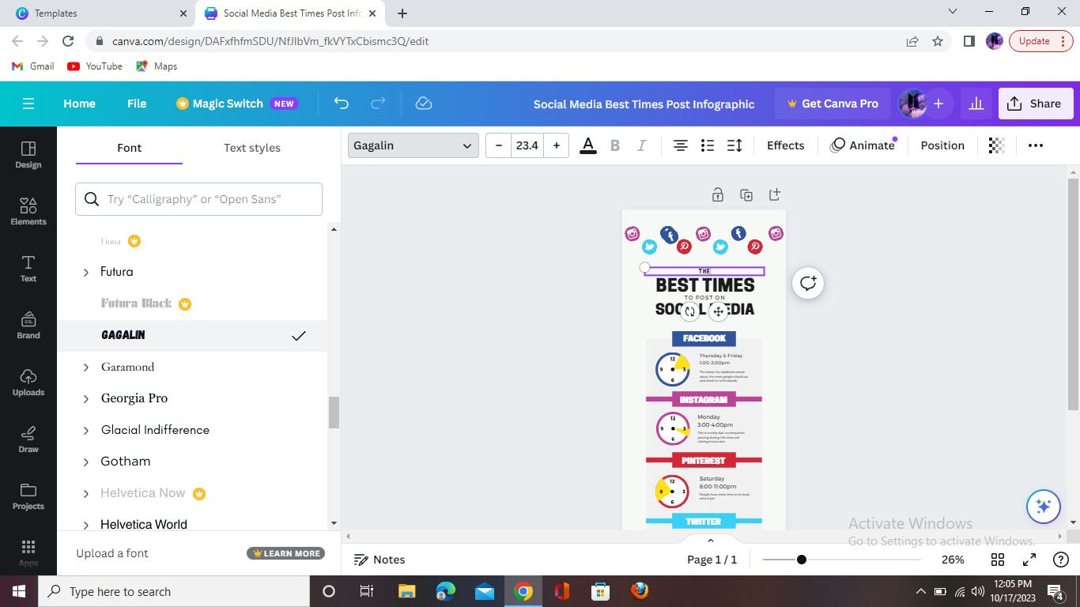

**Mile stone 5:**

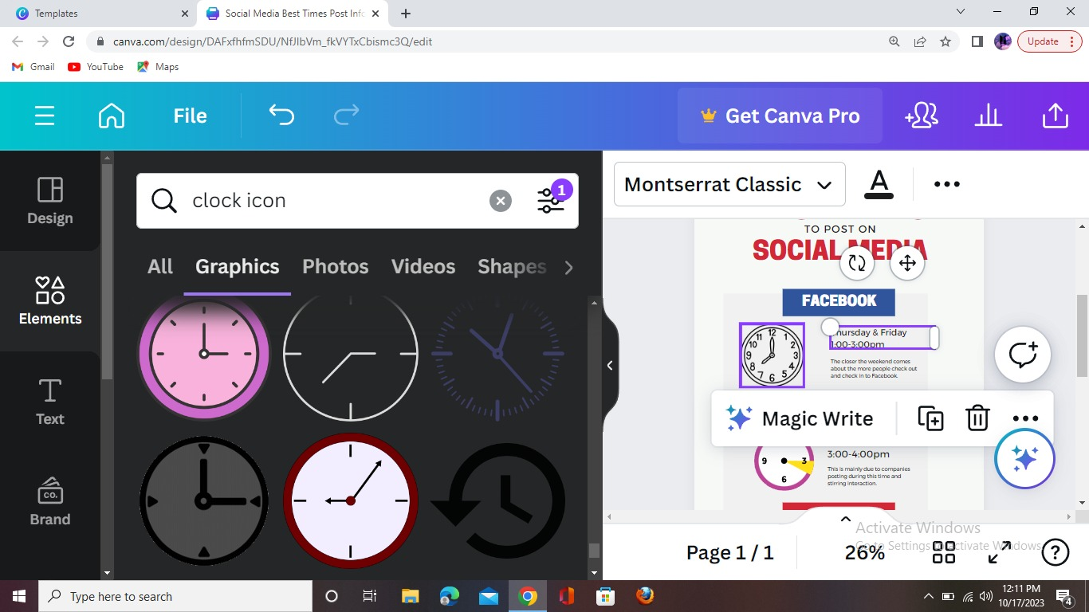

**Mile stone 6:**



**Mile stone 7:**

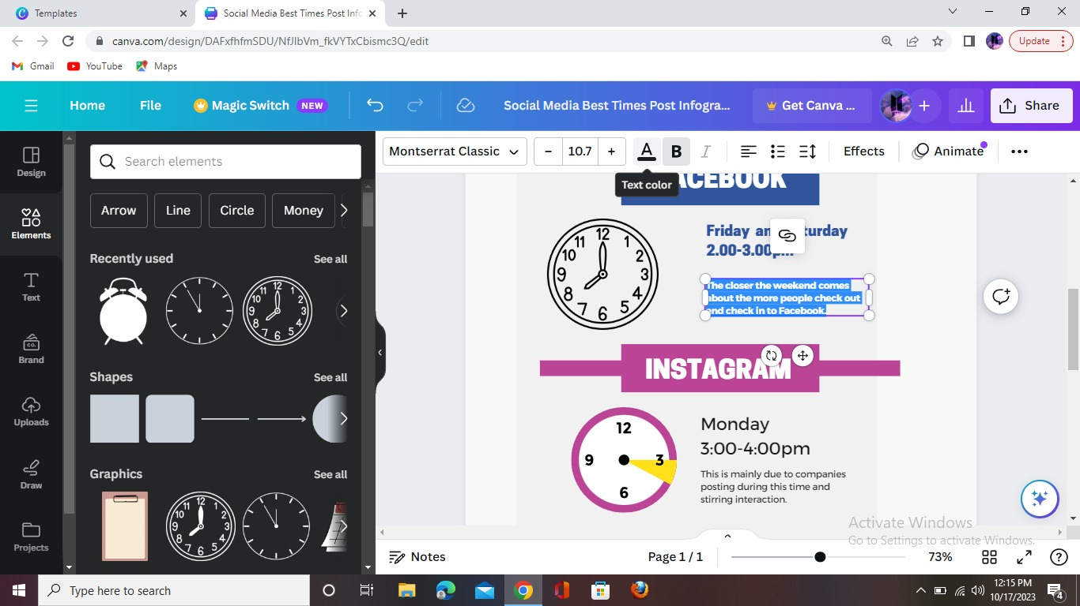

**Mile stone 8:**

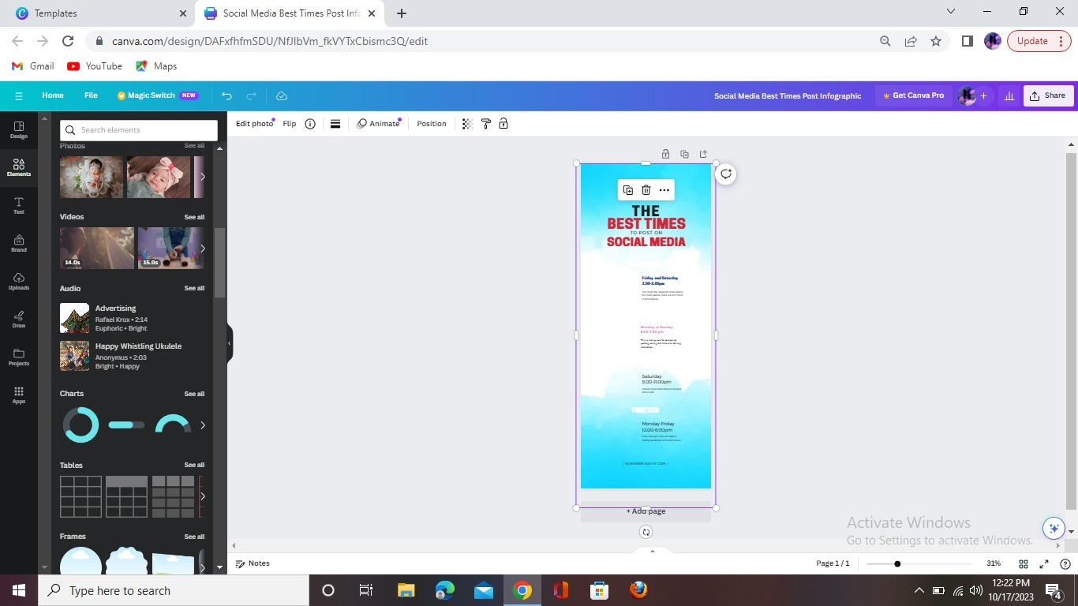

**Mile stone 9:**

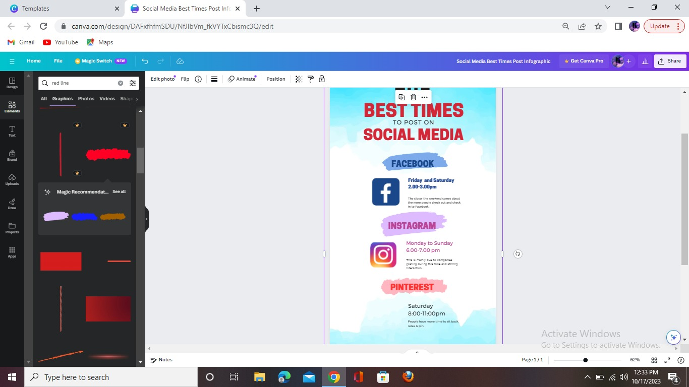

**Mile stone 10**

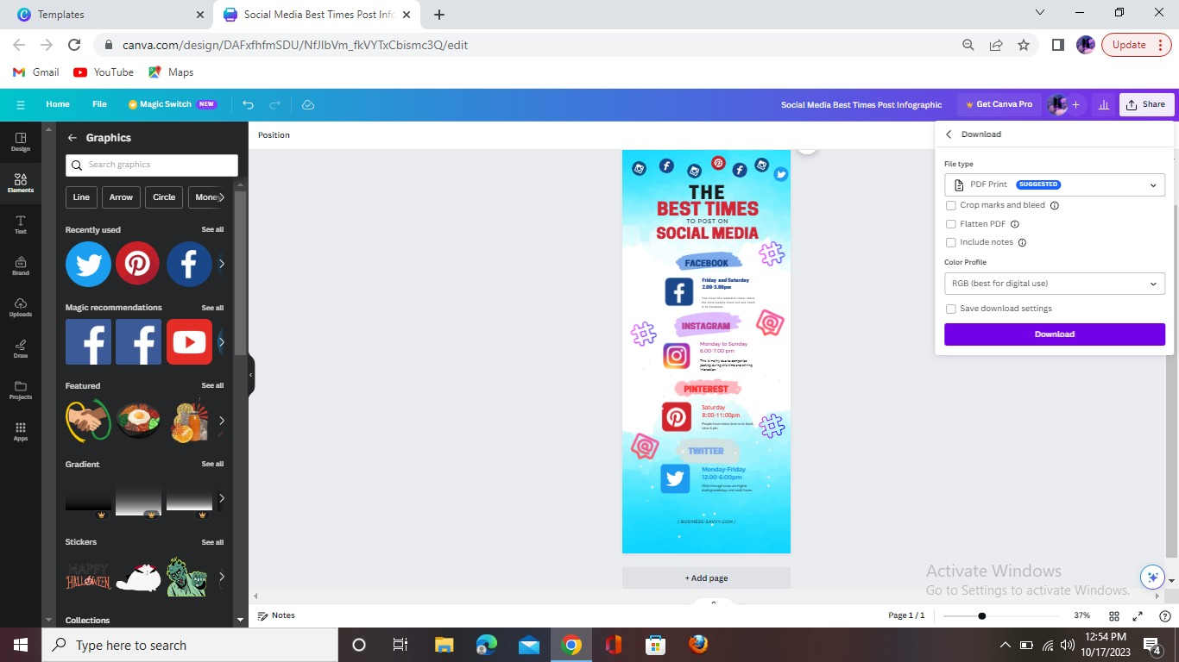

**Advantages :**

* + - * **Build your brand**
      * **Social media allows to reach a large audience and build your brand.**
      * **One can share relevant information or content with audience, which is helpful to follow the business on social media.This can help promote business or product, which will help to increase sales.**
      * **It helps audience to analyse the media posts**
      * **Anyone can be a designer using canva**
      * **Canva is very simple to use & user friendly**

**Disadvantages:**

* **Somany paid temlplate that we can’t use**
* **The free version is limited in terms of stock photography,templates,fonts,brand kit,team sharing storage and support**
* **Limitation of number of templates:**

**Although Canva’s contribution is growing every month, there is a limitation to template designs and stock photography.**

* **Alignment concerns:**

**No alt text provided for this image**

**Canva is not for designers. One of the greatest issues is that of alignment. Whereas software like Photoshop and Illustrator and InDesign, alignment can be carefully controlled, Canva is not as controllable in terms of design elements.**

* **Intellectual property belongs to Canva:**

**Intellectual property is ambiguous. You do not own anything, but have usage licensing.**

**Specifically, when it comes to logos on Canva, you do not have a differentiated logo, but also, it isn’t yours.**

**CONCLUSION:**

**Working on their own can boost productivity and take Canva to the next level with time-saving premium features. Take the hassle out of cropping and resizing your design with Magic Resize, oDesign with ease – Canva makes creating content for Social Media easy with thousands of templates for every social channel, a drag-and-drop editor, and an unlimited content library full of stickers, graphics, fonts, shapes, videos, photos, audio, and reorganized your photos into folders, and save your brand logo, colors, and fonts.**

**Design with ease - Canva makes creating content for Social Media easy with thousands of templates for every social channel, a drag-and-drop editor, and an unlimited content library full of stickers, graphics, fonts, shapes, videos, photos, audio, and more! :**

**FUTURE SCOPE:**

* **Its helps to develop students knowledge and skills. There are few potential ways to earn money by using canva design platform in the future.**